Ketchup®︎

www.aesop.com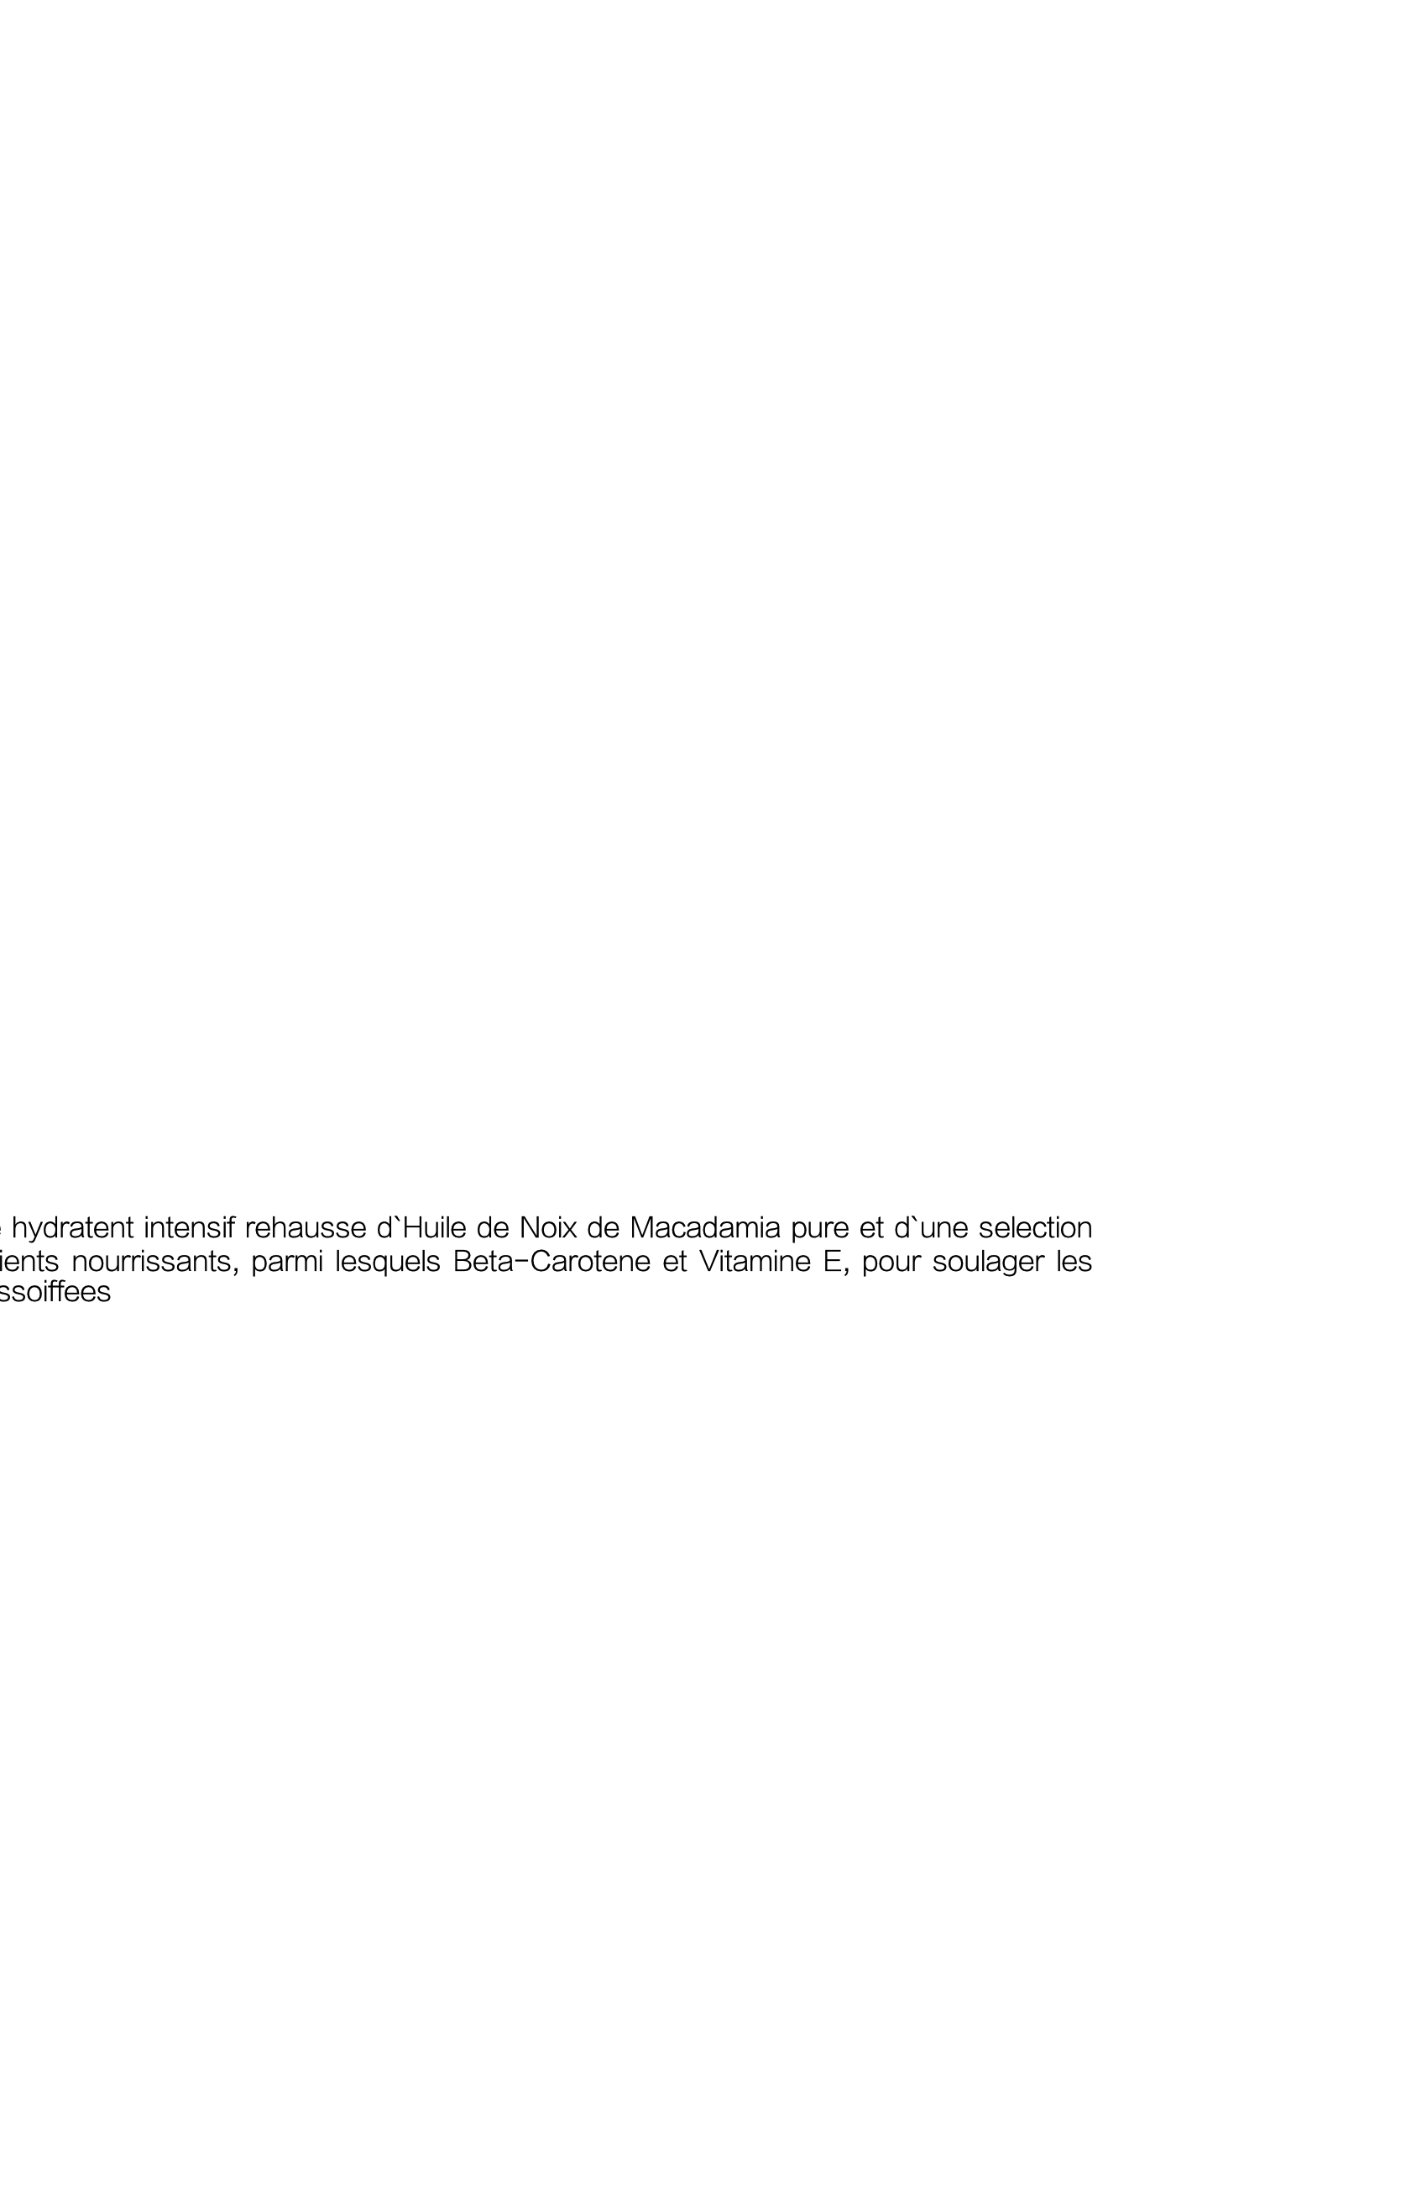

Intensive moisuring balm enhanced with pure Macadamia Nut Oil and a selection of nourishing ingredients, including Beta-Carotene and Vitamin E, to relieve parched skin.

Rejuvenate Intensive Shampoo

Baume Intensif Rajeunissant pour le Corps

Tangerine Rind · Vanille · Sandalwood

Ecorce de Tangerine,Vanille, Bois de Santal

Beaume hydratent intensif rehausse d`Huile de Noix de Macadamia pure et d`une selection d`ingredients nourrissants, parmi lesquels Beta-Carotene et Vitamine E, pour soulager les peaux assoiffees

-︎

This luxurious, greaseless balm will leave your skin infused withwarm notes of tangerine and Sandalwood.

Massage generously into freshly cleansed skin for neck to toe, concentrating on dry areas such as elbows and knees.

Reapply as desired.

Net wt 17.0oz e500mL

This luxurious, greaseless balm will leave your skin infused withwarm notes of tangerine and Sandalwood.

Massage generously into freshly cleansed skin for neck to toe, concentrating on dry areas such as elbows and knees.

Reapply as desired.

Ketchup®︎

www.aesop.com

Intensive moisuring balm enhanced with pure Macadamia Nut Oil and a selection of nourishing ingredients, including Beta-Carotene and Vitamin E, to relieve parched skin.

Rejuvenate Intensive Conditioner

Baume Intensif Rajeunissant pour le Corps

Tangerine Rind · Vanille · Sandalwood

Ecorce de Tangerine,Vanille, Bois de Santal

Beaume hydratent intensif rehausse d`Huile de Noix de Macadamia pure et d`une selection d`ingredients nourrissants, parmi lesquels Beta-Carotene et Vitamine E, pour soulager les peaux assoiffees

-︎

This luxurious, greaseless balm will leave your skin infused withwarm notes of tangerine and Sandalwood.

Massage generously into freshly cleansed skin for neck to toe, concentrating on dry areas such as elbows and knees.

Reapply as desired.

Net wt 17.0oz e500mL

This luxurious, greaseless balm will leave your skin infused withwarm notes of tangerine and Sandalwood.

Massage generously into freshly cleansed skin for neck to toe, concentrating on dry areas such as elbows and knees.

Reapply as desired.